Bill of Materials
PART # | DESCRIPTION | QTY.
WFO 1380-1 | Duramax Front Upper 2" Round Bump Stop Bracket for 3" kit | 2
ENE 9.9101G | Round Bump Stop 2.125” Tall | 2

InSTRUCTIONS:
- You will want to mount the new WFO metal bump stop bracket on the outside of the frame, with the bent pieces facing upward; placed in-between the front shock tower legs but slightly forward (not centered).
- To find the mounting position of the bracket, measure 4.25” from the back leg of the shock tower toward the front of the truck. This is where the back of the bump stop bracket will be. Tack in place.
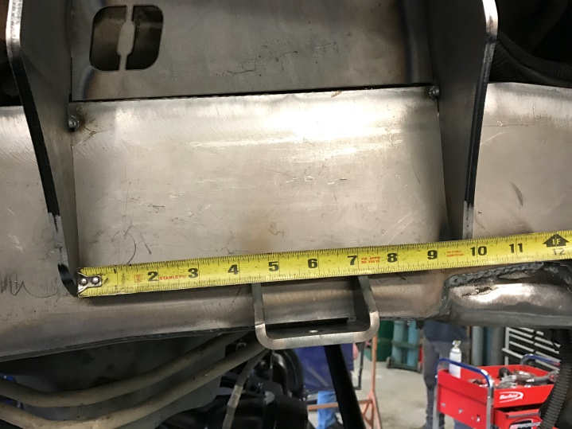
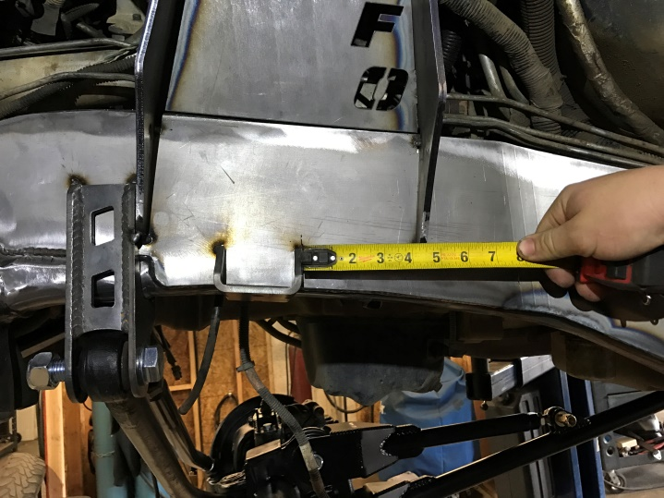

- Cycle the suspension to make sure the rubber bump stop will make contact with the OEM bump pad on the ‘05+ Superduty axle. When you are pleased with the location, weld the bracket onto the frame then, bolt the round bump stop onto the WFO metal bump stop bracket.

